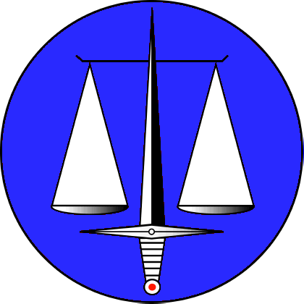

Studiecentrum voor Militair Recht en Oorlogsrecht v.z.w.
Centre d’Etude de Droit militaire et de Droit de la Guerre a.s.b.l.

(Belgian Group of the
International Society for Military Law and the Law of War)

SEMINAR – 10 NOVEMBER 2022

APPLICATION FORM

This Seminar is open to members of the Belgian Group of the International Society for Military Law and the Law of War, as well as to academics, practitioners and students active in the field of international humanitarian law. As the number of available places is limited, we will apply the ‘first comes first meals principle’ while giving priority to members of the Belgian Group of the International Society for Military Law and the Law of War until 10 October 2022. Non-members of the Belgian Group who wish to attend the Roundtable will receive news as of 11 October 2022 on whether or not their application is accepted. Applications that reach us after 4 November 2022 will in principle not be accepted.

Please fill in this form legibly and send it by 4 November 2022 at the latest to:

brussels@ismllw-be.org

NAME & FIRST NAME
ADDRESS
PROFESSION / RANK
ORGANISATION
SERVICE
TEL
E-MAIL

APPLICABLE PARTICIPATION FEE

□ I’m a member of the Belgian Group of the International Society for Military Law and the Law of War no participation fee.
□ I’m not a member of the Belgian Group of the International Society for Military Law and the Law of War:
□ I work for the Belgian Justice sector the participation fee (20 euro) needs to be paid via the SPF Justice/FOD Justitie.
□ I’m a student reduced participation fee (10 euro)
□ I’m not part of one of the previous categories participation fee (20 euro) to be paid on account BE27 0000 9410 7073 of the Belgian Group of the International Society for Military Law and the Law of War before the start of the event.

PRIVACY
Our privacy policy applies.
See: https://www.ismllw-be.org/nl/privacybeleid-2/ (in Dutch) and
https://www.ismllw-be.org/declaration-de-confidentialite/ (in French)

By registering for this event you give permission to the Belgian Group of the International Society for Military Law and the Law of War, and its office holders and staff to take pictures of participants at the event. You also give permission to use these pictures for communication purposes (Tweets, LinkedIn posts by office holders, photo gallery of the website…) of the Belgian Group of the Society.

Date and signature

